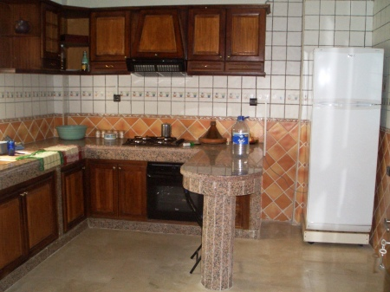
Typical kitchen in Morocco

I stumbled across this pic in my pic folder: I’d like to find more pictures of this nature. Here’s a glimpse of fresh-living in Morocco. Notice the size of the refrigerator? Most fruits and vegetables are purchased and consumed on a daily basis, not too much fits, or is stored in refrigerators out here. Everything is purchased fresh and consumed daily.. By Lorie Ann Jermoune

